**B.B.A. SEMESTER - IV**

**INCOME TAX – LAW AND PRACTICE**

**UNIT 2 INCOME UNDER THE HEAD SALARY**

**Conditions For Taxability Under This Head [Section 15]**

1. There must be some services rendered during the previous year;
2. The payment must be made for such services;
3. The relationship must be of employer and employee.

**Non-applicability Of This Head**

The following are not chargeable under the head of income from salary, as there’s no employer-employee relationship:

1. MLAs or MPs, as they are not treated as employees of government
2. Salary received by a partner from the partnership firm
3. Payment received by a guest lecturer

**Basis of charge [Section 15]**

* Salary is taxable on accrual or receipt basis, whichever is earlier.
* Salary is taxable, whether received from the present or former employer.

**Meaning of Salary [Section 17(1)]**

* Salary includes both monetary and non-monetary payments, and includes all of the following:
* Basic salary/ wages
* Any annuity or pension
* Any gratuity
* Any fees, commission, perquisites, profit in lieu of or in addition to salary/ wages
* Leave encashment
* Any taxable allowances
* Employer’s contribution to Recognized Provident Fund
* Interest credited in Recognized Provident Fund account
* Contribution made by Central Government or any other employer to employee’s account under Pension Scheme referred in Section 80CCD
* Loan given to employee or advance against salary is not taxable.

**Allowances**

* Allowances are fixed monetary amount paid by the employer to the employees for meeting certain specific expenses.
* Allowances are given in addition to salary.
* Allowances can be divided into three categories:
* Fully Exempt
* Fully Taxable
* Partly Exempt and Partly Taxable
* The bifurcation of the same is as under:

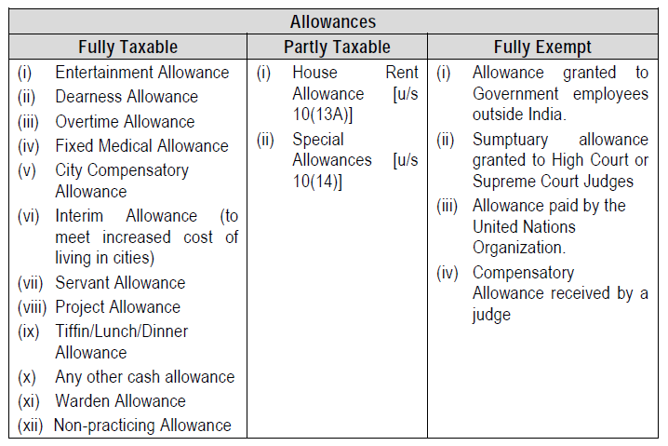

**House Rent Allowance [Section 10(13A)]**

* Least of the following is exempt from the House Rent Allowance received:

1. Actual HRA; OR
2. 50% [Metro*(D/K/M/C city]/ 40% [Non-metro city] of Salary
3. Rent paid – 10% of Salary

Here, Salary = basic + dearness allowance + commission as % of turnover.

*Metro Cities shall include Delhi, Mumbai, Chennai and Kolkatta.

Thus, Taxable HRA = Actual HRA received – HRA exempt (least of above)

* This exemption shall be available only if the employee stays in a rented house and makes payment of rent.

*Illustration 1:*

Mr. Bajirao (working in Mastani Realities, **Pune**) has received the following benefits:

Basic Salary Rs. 10,000 p.m.

Dearness Allowance Rs. 5000 p.m.

Commission (10% of turnover) Rs. 60,000

House Rent Allowance Rs. 5000 p.m.

Bajirao has paid Rs. 6000 p.m. as house rent. Compute his Gross Salary for A.Y. 2017-18.

HRA RECEIVED – RS 60000 – RS 48000 EXEMPT = TAXABLE HRA 12000

1. Actual HRA; **60000** OR
2. 40% [Non-metro city] of Salary = 240000*40%= **96000**
3. Rent paid – 10% of Salary =72000-24000 **= 48000**

BASIC SALARY = 10000*12 = 120000

+ DEARNESS ALLOWANCE = 60000

+ COMMISSION ON TURNOVER = 60000

TOTAL SALARY (FOR HRA) = 240000

[Solution: Rs. 2,52,000 (HRA Rs. 12,000)]

*Illustration 2:*

From the following details, compute Gross Salary of Ms. Kajal (who’s working in Mumbai) for A.Y. 2017-18:

Basic Salary Rs. 12,500 p.m.

Dearness Allowance Rs. 5500 p.m.

Commission Rs. 1000 p.m.

Turnover Rs. 13,00,000

Commission is also given at 10% of turnover

House Rent Allowance Rs. 12,000 p.m.

Kajal has paid Rs. 10,000 p.m. as house rent.

[Solution: Rs. 4,16,600 (HRA Rs. 58,600)]

**Special Allowances**

* For the following allowances, lower of actual amount spent or allowance received is exempted:

1. Travelling allowance
2. Daily allowance
3. Conveyance allowance
4. Helper allowance
5. Academic allowance
6. Uniform allowance

* For the following allowances, lower of allowance received or the limit specified is exempted:

|  |  |  |
| --- | --- | --- |
| Sr. No. | Allowance | Limit Specified (Maximum Exemption) |
| 1. | a) Transport allowance (from residence to office and back)  b) Transport allowance for handicapped/dumb/deaf (from residence to office and back) | FULLY TAXABLE  Rs. 3200 p.m. |
| 2. | Children Education Allowance | Rs. 100 p.m. per child (maximum 2 children) |
| 3. | Children Hostel Allowance | Rs. 300 p.m. per child (maximum 2 children) |

*Illustration 3:*

Mr. Mohit works with X Ltd. He has received the following emoluments:

|  |  |
| --- | --- |
| Particulars | Amt. (Rs.) |
| Basic Salary | 1,62,000 p.a. |
| Daily Allowance (actual expense Rs. 1500 p.m.) | 1200 p.m. |
| Helper Allowance (actual expense Rs. 1000 p.m.) | 1280 p.m. |
| Transport Allowance | 2000 p.m. |
| Children Education Allowance (for 2 children) | 1500 p.a. |
| Hostel Allowance (for 2 children) | 2000 per child p.a. |
| City Compensatory Allowance | 6000 p.a. |
| Medical Allowance | 500 p.m. |
| Overtime Allowance | 2000 p.m. |

Find out his Gross Salary for A.Y. 2021-22.



[Solution: Rs. 2,06,160]

**Retirement Benefits : Gratuity**

* Gratuity is one type of benefit given to employees at the time of their retirement. Gratuity means a voluntary payment made by an employer in appreciation of services rendered by the employee.
* Gratuity received by an employee while in service is fully taxable.
* Gratuity received at the time of retirement is exempted, subject to certain conditions and calculations. The maximum amount allowed as exemption for gratuity is Rs. 20,00,000.
* Gratuity received at the time of death of employee is fully exempted in the hands of the legal heirs.

**Retirement Benefits : Pension**

* Pension is divided into two categories: commuted and uncommuted.
* Uncommuted pension is a periodic payment to the employee by his former employer. It is fully taxable in the hands of the employee.
* Commuted pension is a one time, lump sum payment, received by the employee. Commuted pension is fully exempt for government employees. For non-government employees, commuted pension is partially exempted.

**Leave Encashment**

* The accumulated leave standing to the credit of an employee may be availed by an employee during his service time or such leaves may be allowed to be encashed at the time of retirement or leaving the job.
* Encashment of leave while the employee is in service shall be fully taxable.
* Encashment of accumulated leave at the time of retirement is exempt, subject to certain conditions and calculations. [Maximum exemption is Rs. 3,00,000].

**Retrenchment Compensation**

* It is the compensation received by the employee at the time of closing down, under any dispute, orders of court, service contract or in any other manner at the time of retrenchment.
* Retrenchment compensation received in accordance with any scheme which is approved by the Central Government is fully exempt.
* Retrenchment compensation received in any other case is exempt, subject to certain conditions and calculations. [Maximum exemption is Rs. 5,00,000].

**Provident Fund**

* Provident fund scheme is a scheme intended to give substantial benefits to an employee at the time of retirement.
* Under this scheme, a specified sum is deducted from the salary of an employee as his contribution towards the fund. The employer also generally contributes the same amount to the fund. The contributions are invested in approved securities. Interest earned is also credited to the PF account.
* Thus, the credit balance in provident fund account of an employee consists of the following:
* Employee’s contribution
* Interest on employee’s contribution
* Employer’s contribution
* Interest on employer’s contribution
* There are four types of Provident Funds:

1. Statutory Provident Fund

This is governed by the Provident Fund Act, 1925 and is applicable to government employees.

1. Recognized Provident Fund

This is a provident fund recognized by the Commissioner of Income-tax.

1. Unrecognized Provident Fund

This is a provident fund not recognized by the Commissioner of Income-tax.

1. Public Provident Fund

This is a provident fund operated under the Public Provident Fund Act, 1968. Membership to this fund is open to every individual.

* The tax treatment is as under:

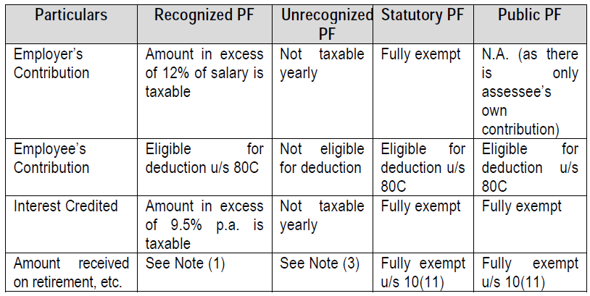

Notes:

1. Amount received on maturity of Recognized Provident Fund is fully exempt in case of an employee who has rendered continuous service for a period of 5 years.

In all other cases, it is taxable in the same manner as Unrecognized Provident Fund.

1. If employee terminates service at one organisation and takes employment elsewhere, then the balance of his individual provident fund account transferred to the new organisation shall be fully exempt.
2. In case of Unrecognized Provident Fund, employee’s contribution is exempt, but interest thereon is taxable under ‘Income from Other Sources’. Employer’s contribution and interest thereon is taxed as ‘Income from Salary’.
3. Here, Salary = Basic Salary + Dearness Allowance (if paid in connection with retirement benefits) + Commission as % of turnover.

**Perquisites**

* Perquisites are the benefits and amenities provided by the employer to his employee, in addition to normal salary.
* It may be cash in kind. It may be provided at free of cost or at a concessional rate.
* Definition [Section 17(2)]: Perquisites include –
* Value of **RENT-FREE ACCOMMODATION** provided to the employee by the employer
* Value of any concession, in case of accommodation provided at concessional rate
* Value of any benefit or amenity granted or provided free of cost or at concessional rate to a specified employee
* Any sum paid by the employer in respect of any **OBLIGATION OF THE EMPLOYEE**, which otherwise would have been payable by the employee
* Any sum payable by the employer, whether directly or through a fund to effect an assurance in life of the employee or to effect a contract of an annuity
* The value of any specified **SECURITIES OR SWEAT EQUITY SHARES** allotted or transferred to employees by an employer at free of cost or concessional rate
* The amount contributed by the employer to an approved **SUPERANNUATION FUND** in excess of Rs. 1.50 lakh
* The following perquisites are **FULLY EXEMPT** from tax in the hands of all the employees:

1. **Refreshments (tea or snacks)** provided during working hours
2. **Free meals** provided during working hours **in a remote area** or off-shore installation (**in other areas, upto Rs. 50 per meal is exempt**)
3. **Recreational facilities** provided uniformly to all employees
4. **Telephone facility** provided at residence of employee for official and personal purposes
5. Employer’s contribution to staff group insurance scheme
6. Payment of annual premium by employer on personal accident policy effected by him on his employee
7. Amount spent by the employer on any refresher courses attended by the employees
8. Perquisites allowed outside India by government to Indian citizen for rendering services outside India
9. Rent-free house to High Court and Supreme Court judges
10. Rent-free furnished residence (including maintenance) provided to an Officer of Parliament, a Union Ministry and a leader of opposition in Parliament
11. Conveyance facility to High Court and Supreme Court judges
12. Travelling facility to employees of Railways or Airlines
13. Accommodation provided on transfer of employee in a hotel for not exceeding 15 days in aggregate
14. **Computer/ laptop** given (not transferred) to an employee for official/ personal use
15. **Free educational facility** to the children of employee in an educational institute owned/ maintained by the employer if cost of such education or value of such benefit **does not exceed Rs. 1000 p.m. per child**
16. **Interest free/ concessional loan** to an employee if the amount of loan does not exceed Rs. 20,000
17. Periodicals and journals for official use
18. Tax on non-monetary perquisites paid by employer
19. Gift in kind below Rs. 5000

**Deductions from Salary**

The following shall be allowed as deduction from the salary income of an employee:

1. **STANDARD DEDUCTION [SECTION 16(ia)]**

Flat Rs. 50,000/- p.a.

1. **Entertainment Allowance [Section 16(ii)]**

* This deduction is available only to government employees.
* Entertainment allowance received is fully taxable and is first to be included in the salary. Thereafter, lower of the following shall be deducted:

1. Actual amount of entertainment allowance received
2. Rs. 5000
3. 20% of Basic Salary
4. **Professional Tax [Section 16(iii)]**

* Professional Tax or Tax on Employment is charged by State Government.
* Professional tax shall be fully allowed as deduction from the salary income of employee, only if it is paid by the employee during the previous year.

**HOW TO COMPUTE INCOME FROM SALARY?**

|  |  |
| --- | --- |
| **PARTICULARS** | **AMOUNT (RS)** |
| Basic Salary | XX |
| Bonus | XX |
| Commission | XX |
| Taxable Allowances | XX |
| Taxable Perquisites | XX |
| Taxable Retirement Benefits | XX |
| **GROSS SALARY** | **XX** |
| **Less: Deductions u/s 16:-** |  |
| 1. Standard Deduction | (50000) |
| 1. Entertainment Allowance (Only to Govt. Employee) | (XX) |
| 1. Professional Tax / Tax on Employment | (XX) |
| **NET SALARY / TAXABLE SALARY** | **XX** |

*Illustration 4:*

Ms. Shikha, a **government employee**, gets Rs. 40,000 p.m. as basic pay. In addition, she receives Rs. 8500 as entertainment allowance. She has paid Rs. 2,500 as professional tax. Calculate her Net/ Taxable Salary for A.Y. 2022-23.

SOLUTION:

**STATEMENT SHOWING TAXABLE SALARY**

|  |  |
| --- | --- |
| **PARTICULARS** | **AMOUNT (RS)** |
| Basic Salary (40000*12) | 4,80,000 |
| Bonus | XX |
| Commission | XX |
| Taxable Allowances |  |
| ‘- Entertainment Allowance | 8,500 |
| Taxable Perquisites | XX |
| Taxable Retirement Benefits | XX |
| **GROSS SALARY** | **4,88,500** |
| **Less: Deductions u/s 16:-** |  |
| 1. Standard Deduction | (50000) |
| 1. Entertainment Allowance (Only to Govt. Employee)[NOTE-I] | (5000) |
| 1. Professional Tax / Tax on Employment | (2500) |
| **NET SALARY / TAXABLE SALARY** | **4,31,000** |

NOTE – I : DEDUCTION FOR ENTERTAINMENT ALLOWANCE:

1. EA Received – 8500
2. 20% of Basic Salary (480000*20%) – 96000
3. RS 5000

WE IS LESS – RS 5000